Biosonics™ Tuning Forks: Tools that bring our nervous system “in tune.”
Information presented from John Beaulieu’s book Human Tuning

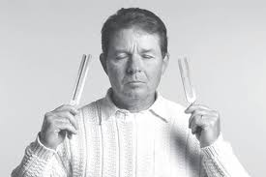
Dr. John Beaulieu, Founder of Biosonics Tuning Fork System

Our bodies can be tuned like musical instruments. When they are properly tuned we have a sense of well-being and perfect self-expression.
Athletes and performers describe being in tune as a state of profound inner relaxation during performance. They are referred to as being “highly tuned” or “in the zone.” When we are “in tune” we are able to make better choices. We have the ability to successfully adapt to the stresses of life giving us better health and increased wellness.
Tuning forks are evidence-based tools which when played create a balancing effect on the central nervous system. The research of Dr. John Beaulieu shows that the Otto 128 tuning forks spike nitric oxide. The boost of nitric oxide balances the autonomic nervous system (responsible for digestion, heart rate, respiratory rate, pupillary response, urination, sexual function) and signals a natural release of anti-bacterial, anti-virals, and free radicals on a microcellular level. Decreased nitric oxide spiking production leads to depressed immune function which over time results in tissue pathology.
Symptoms of decreased nitric oxide spiking may include:
●lack of energy
●joint pain
●depression
●poor digestion
●decreased sexual drive
●headaches
●memory loss
If nitric oxide rhythms aren’t restimulated over time, larger problems may arise including cardiovascular disease, diabetes, Alzheimer’s, autoimmune diseases, and cancer (chronic illness).
I use a variety of Biosonic™ tuning forks, including:
Osteophonic (Otto) Tuning Forks:
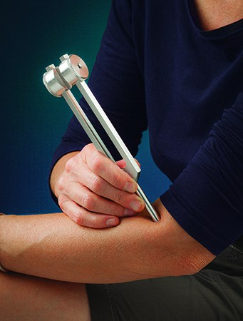
Otto Tuning Forks are placed directly on the body
“The vibration will effect a spike in nitric oxide in both nerve and vascular tissue which leads to vasodilation, nervous system balance, and an increase in opiate molecules (responsible for inner calm). The result in enhanced circulation and less pain (123).”
Otto tuning forks are placed directly on the body. When placed on bone (i.e. the sacrum or sternum), the bone acts as an amplifier and sends the therapeutic pulse into the surrounding nerves, muscles, and other anatomy. You may even hear your body vibrating audible tones of the tuning forks! Otto tuning forks also gently shift into the parasympathetic nervous system (states of rest and repair). The result is deep relaxation and an increased ability to be more receptive.
The main benefits of Otto tuning forks are:
●Relaxing tense tissues around any joint
●Spiking nitric oxide
●Ease into parasympathetic states of repair
●Working with acupuncture points
Brain Tuners:
“Getting things done requires the vision of Alpha, the deep resources of Theta, and the good night’s sleep of Delta (146).”

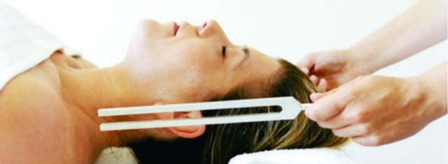
Brain Tuner forks are tapped and listened to off the body

The Brain Tuners are designed to signal the brain to shift into different states of awareness, called Delta, Theta, Alpha, and Beta. Although we naturally shift into each of these states in a 24-hour period, hectic and stressful daily life may cause Beta states to dominate (heightened alertness, “go go go” mentality, leading to burnout. The Brain Tuners may be used to allow for the other states of awareness to become more balanced. The brain quickly entrains (mimics the frequency) with these tuning forks and a client will take a deep breath and quickly experience a deeper sense of relaxation. When two Brain Tuners are sounded, a pulse or binaural beat is heard. This synchronizes the brain to the desired state of awareness (Beta, Theta, Alpha, or Delta).
Delta: Associated with deep sleep.
Connection to our source, the Universal Energy Field, which provides the energy to repair and revitalize our body and mind.

Theta: Twilight state.
Receptive to information from our superconscious mind and better able to hear the voice of the healer within.
Access to intuition.

Alpha: Being relaxed and centered during activity
(i.e. “The Zone”)
Heightened states of learning – processing information at a high rate
Creative waking states.

Beta: Heightened alertness
Peak concentration

While it is important to express all wavelengths, we can get stuck in the higher frequencies of Beta states of being (often associated with stress or “go go go, do do do” lifestyles). Functioning at a high level of wellness requires shifting into and out of Delta, Theta, Alpha, and Beta states throughout a 24-hour period. As a car needs to shift gears to meet the needs of hills, descents, and cruising, we need to shift in and out of different states of awareness to meet the challenges of life.

Fibonacci Tuning Forks:

“The main purpose of the Fibonacci Tuning Forks is to open gateways into alternate realities and to explore higher states of consciousness in order to empower a creative healing response (95).”
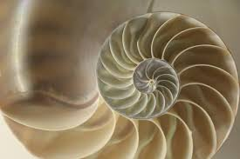
The Fibonacci spiral is seen in seashells and throughout nature
Fibonacci Tuning Forks work on a similar premise to that of reflexology: you can effect change by working remotely from the direct source of pain or dysfunction. For instance, when a client has a broken bone or very tender area of their body, reflexology points can be used to safely access and treat these areas. Likewise, Fibonacci Tuning Forks allow altered states of being, in which we can access information which feels more safe and accessible than normal states of being. These tuning forks are particularly indicated in working with clients who have experienced trauma, abuse, and/or addiction but I incorporate these tuning forks into many bodywork sessions.
Fibonacci Tuning Forks work specifically with:
●grief and loss
●increased feelings of wellbeing
●centering
●enhanced dreaming and visualization
●clarity of vision
●contacting the healer within
●letting go of unwanted thoughts
●a deep sense of simplicity
●revealing great inner truths
●entry into higher states of knowledge, spiritual wisdom

Click here to experience the gentle vibration of tuning forks and to schedule a session with Jennie

Salamon, Elliott, Kim, Minsum, Beaulieu, John, Stefano, George B. “Sound therapy induced relaxation: down regulating stress processes and pathologies” John Beaulieu Human Tuning. High Falls, NY: Biosonic Enterprises, Ltd, 2010, p. 176.

