B E I N G I N ”full body meditation”
B A L A N C E ®
Jennie Finn, Licensed Massage Therapist
Light Touch Bodywork for Chronic Pain and Stress Relief
401 575-7379 BIBJennieFinn@gmail.com MT01047
BeingInBalanceJennieFinn.com

Why the Vagus Nerve Needs to Be Included When Looking At the “Whole Picture” of Health
During your next session, you will likely hear me talk about The Polyvagal Theory, the ventral branch of the vagus nerve, or introduce you to “The Basic Exercise.” The information I am presenting in this article refers to a book I’m very excited about, Accessing The Healing Power of the Vagus Nerve: Self-Help Exercises for Anxiety, Depression, Trauma, and Autism by Craniosacral Therapist and Rolfer Stanley Rosenberg. He has taken the principles of the Polyvagal Theory by Stephen Porges and modified them to be used directly with the body…very exciting!

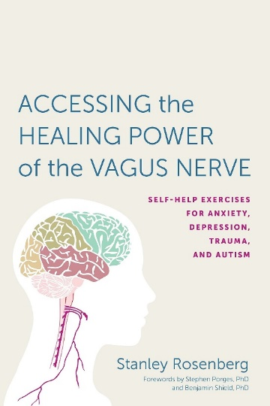
Major benefits in working with the vagus nerve and cranial nerves:
- Increased circulation at the base of the neck and head
- Increased feelings of social engagement and connection
- Reduced feelings of anxiety and/or depression
- Reduction of a myriad of symptoms throughout the body (listed at the end of this article)
- Increased resilience of the nervous system to bounce back into healthy states of functioning after a traumatic or stressful event.

Many of you know that I transitioned to mind-body work because I was looking to address the root causes of chronic pain rather than to chase symptoms. Working with the vagus nerve – specifically the ventral branch of the vagus nerve – is one of the most important starting points for many physical and emotional symptoms. The vagus nerve must function properly for us to be healthy, feel good emotionally, and interact positively with friends, family, and others (p. 36).

In the Polyvagal Model, the vagus nerve has two separate branches that originate in two separate locations and have completely separate functions; they are completely separate entities. (This differs from previous science which only acknowledges one vagus nerve pathway and function).

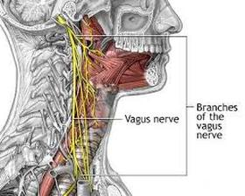
Ventral Branch of Vagus Nerve:
Originates in front side of the brainstem
Associated with positive states of relaxation and social engagement
Most recent branch of vagus nerve to evolve in humans

Spinal Sympathetic Chain (nerves from T1-L2 that connect to visceral organs and head):
Associated with fight or flight response
Increased heart rate
Increased blood pressure
Digestive organs slow
Loss of appetite

Dorsal Branch of Vagus Nerve:
Originates at the floor of the 4th ventricle of the brain
Associated with slowdown, shutdown, and depressive behavior
Immobilization
Oldest branch of vagus nerve to evolve in humans
The Polyvagal Model also states that there is a joint function between the ventral vagus nerve and five of the twelve cranial nerves (nerves which originate in the brainstem) to create healthy states of social engagement.
You may be thinking, “Interesting, but how is this important to me?” Great question!
First, remember that list of symptoms? It’s hard to imagine just how global the effects of a poorly functioning ventral vagus nerve and cranial nerves are until we read through that list. I’m guessing most of us can check off something on that list (refer to attached photos at the end of this article).
Second, prior to the Polyvagal Theory, depression and depressive behavior issues neither fit into the category of stress nor relaxation and thus may have been overlooked in treatment. The body may go into a dorsal vagal state after trauma or overwhelming danger. Symptoms of a dorsal vagal state may include cold, clammy hands, muscles lacking tone, or pains that move to different areas of the body, which may be diagnosed as fibromyalgia. Remaining in a dorsal vagal state robs us of our clarity, productivity, and joy of living until we can get back into a state of social engagement (p. 43). Rather than simply massaging an area that hurts, the best way to treat this condition is to elevate the person from a dorsal vagal state by activating the ventral vagal state, for example with the Basic Exercise (p. 46).
What is the main purpose of the Basic Exercise?
The main purpose of the Basic Exercise is to build resilience and flexibility in the ANS. Inevitably we may still be exposed to stressful or traumatic events throughout our life, but when we are exposed to stressful fight or flight situations (being late for a meeting, the memory of a traumatic situation, being startled) or traumatic events (dorsal vagus circuit), we can recover quickly back to a state of social engagement and wellbeing (ventral vagus circuit) and continue to be socially engaged, connected, healthy, and productive in our lives.
Another purpose of the Basic Exercise is to relax the base of the neck in order to remove restrictions to blood flow to and from the brainstem, where the vagus nerve and other cranial nerves of social engagement originate. The other exercises presented in the book encourage proper movement of the head, neck, and shoulders and encourage proper posture and healthy breathing capacity – all of which play a major role in the overall health of our body systems.
Why do I care about social engagement? I just want my neck to feel better. Social engagement is one of the rewards of being human! When the ventral vagus nerve and associated cranial nerves are functioning optimally and we are in a safe environment, we are in a state of rest and restoration. Optimal physical and emotional health is present and therefore friendship, parent-child bonding, cooperation, and loving relationships can form. This can serve as a positive feedback loop in which we are rewarded by the relationships and bonding formed through this state. When we are socially engaged, we are productive, creative, and happy. States of trust, openness, and optimism in new situations may follow. Mammals are the only organisms (aside from possibly birds) that have a ventral vagus nerve – cool!
Because the ventral vagus nerve evolved more recently than the dorsal vagus nerve branch and the spinal sympathetic chain, when it is activated, the other two circuits are disengaged. Therefore, when we practice the Basic Exercise we are deactivating fight or flight and depressive states of being.
The ultimate goal: The positive effects of the Basic Exercise are cumulative. Our autonomic nervous system becomes more resilient each time we can restore a state of social engagement following activation of the spinal sympathetic chain (fight or flight) or dorsal vagus branch (depressive symptoms). It may be necessary to repeat these exercises occasionally or regularly.
Our long-term goal is to encourage the autonomic nervous system to return naturally, on its own, from a state of stress (spinal sympathetic activation) or depression (dorsal vagal circuit activity) to a state of social engagement (ventral vagal circuit activity) as soon as conditions change for the better and we return to feeling physically and emotionally safe.
LIST OF SYMPTOMS WHICH MAY ORIGINATE FROM VAGUS NERVE/SPINAL SYMPATHETIC CHAIN:

All of the problems in this list occur at least partly from dorsal vagal activity or activation of the spinal sympathetic nervous system, and can be addressed by reinstating normal function of the ventral vagus nerve branch and other nerves required for social engagement (p.6)
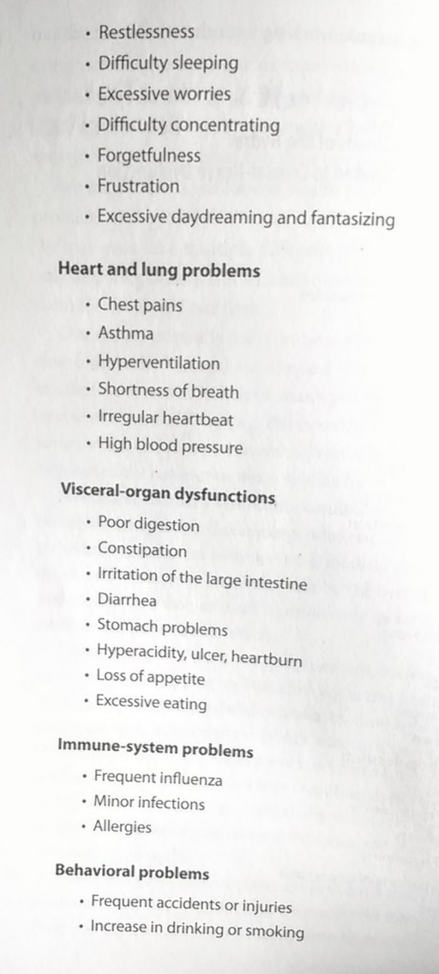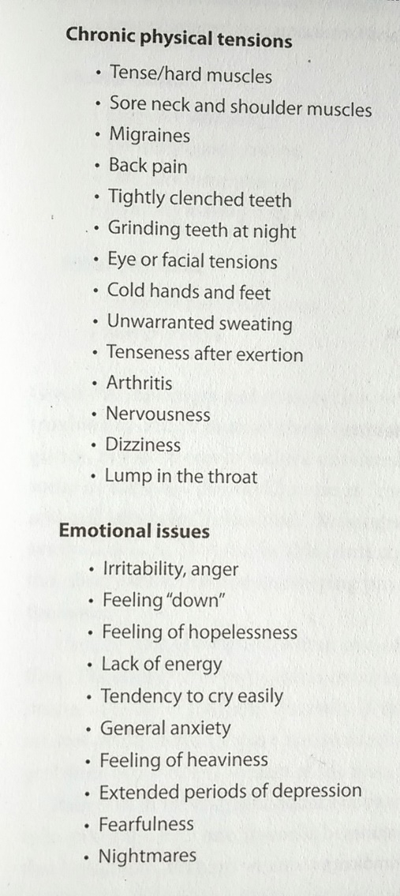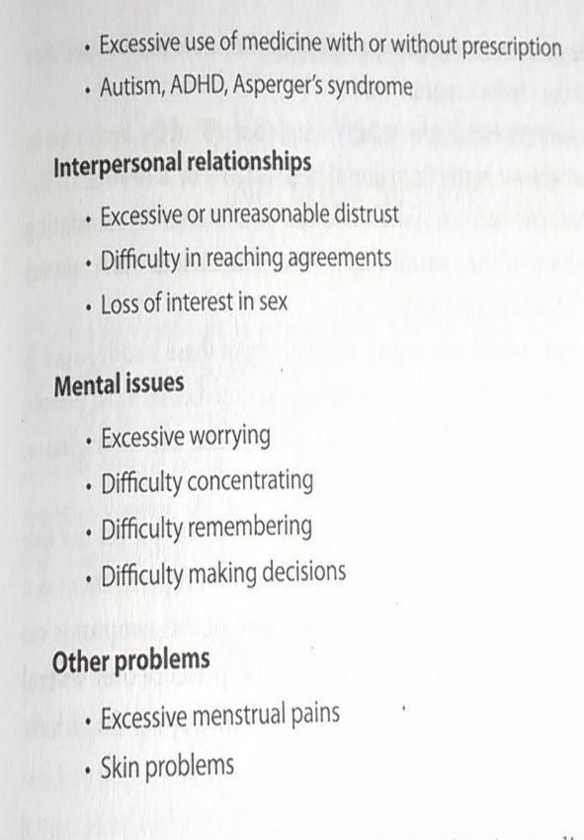
Being In Balance serves to support each client in the realization of their greatest self by evaluating and treating the whole person and their whole system. Jennie strives to find efficient, non-invasive modalities which stimulate your innate ability to self-heal.
Contact Jennie to set up your next session for total-being health.

